Bonus_421

Spandan Biswas

06/04/2022

library(igraph)

## Warning: package 'igraph' was built under R version 4.1.2

##   
## Attaching package: 'igraph'

## The following objects are masked from 'package:stats':  
##   
## decompose, spectrum

## The following object is masked from 'package:base':  
##   
## union

options(digits = 3, scientific = F, scipen = 100)

nodes <- read.csv("vertex911.csv",header=T)  
adj <- read.csv("adj911.csv",header=T)  
adj <- as.matrix(adj)

g_2 <- graph_from_adjacency_matrix(adj, mode = "undirected")

V(g_2)$color <- "blue"  
V(g_2)$color[1:19] <- "red"

plot(g_2,layout=layout.fruchterman.reingold,  
vertex.size=5, vertex.label.cex=.15,edge.arrow.size=.15,  
 vertex.label=NA)

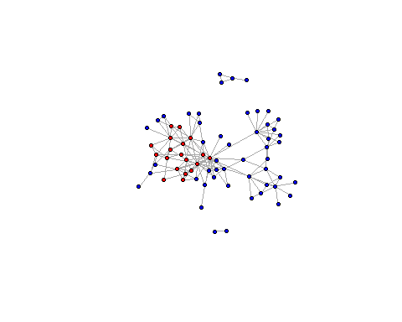

#the hijackers in the network are quite central and very well connected in the network. There are 2 small disconnected components. There is 1 giant component and it contains the hijackers. The hijackers are very well connected to each other

eigen.cent <- eigen_centrality(g_2)  
eigen.node <- eigen.cent$vector  
order <- order(eigen.cent$vector, decreasing = 1)  
eigen.node[order]

## Mohamed.Atta Marwan.Al.Shehhi   
## 1.00000 0.96881   
## Ziad.Jarrah Hani.Hanjour   
## 0.62565 0.60387   
## Abdul.Aziz.Al.Omari Ramzi.Bin.al.Shibh   
## 0.57670 0.54281   
## Fayez.Ahmed Said.Bahaji   
## 0.48910 0.48218   
## Satam.Suqami Wail.Alshehri   
## 0.46575 0.44671   
## Salem.Alhazmi Zakariya.Essabar   
## 0.42959 0.41698   
## Lotfi.Raissi Waleed.Alshehri   
## 0.38383 0.37715   
## Agus.Budiman Nawaf.Alhazmi   
## 0.37360 0.35020   
## Mounir.El.Motassadeq Mustafa.Ahmed.al.Hisawi   
## 0.34490 0.32662   
## Mamoun.Darkazanli Hamza.Alghamdi   
## 0.28617 0.23773   
## Ahmed.Al.Haznawi Ahmed.Alghamdi   
## 0.22905 0.22479   
## Zacarias.Moussaoui Khalid.Al.Mihdhar   
## 0.20337 0.19679   
## Imad.Eddin.Barakat.Yarkas Majed.Moqed   
## 0.19060 0.18208   
## Essid.Sami.Ben.Khemais Rayed.Mohammed.Abdullah   
## 0.14276 0.13336   
## Saeed.Alghamdi Ahmed.Khalil.Ibrahim.Samir.Al.Ani   
## 0.12481 0.11521   
## Abdelghani.Mzoudi Mohammed.Belfas   
## 0.11521 0.10558   
## Nabil.al.Marabh Faisal.Al.Salmi   
## 0.10327 0.08493   
## Bandar.Alhazmi Mohand.Alshehri   
## 0.08493 0.08374   
## Ahmed.Alnami Raed.Hijazi   
## 0.08211 0.08101   
## Abdussattar.Shaikh Osama.Awadallah   
## 0.07122 0.07122   
## Abu.Qatada Tarek.Maaroufi   
## 0.05811 0.05347   
## Djamal.Beghal Mohamed.Abdi   
## 0.04154 0.04035   
## Jerome.Courtaillier Kamel.Daoudi   
## 0.03531 0.03406   
## Mamduh.Mahmud.Salim David.Courtaillier   
## 0.03297 0.02750   
## Mohamed.Bensakhria Ahmed.Ressam   
## 0.02742 0.02596   
## Seifallah.ben.Hassine Essoussi.Laaroussi   
## 0.02261 0.02261   
## Mehdi.Khammoun Haydar.Abu.Doha   
## 0.02214 0.02199   
## Lased.Ben.Heni Samir.Kishk   
## 0.01961 0.01645   
## Madjid.Sahoune Fahid.al.Shakri   
## 0.01645 0.01645   
## Abu.Walid Nabil.Almarabh   
## 0.01540 0.00933   
## Nizar.Trabelsi Abu.Zubeida   
## 0.00479 0.00479   
## Jean.Marc.Grandvisir Mohammed.Jaweed.Azmath   
## 0.00479 0.00000   
## Ayub.Ali.Khan Karim.Koubriti   
## 0.00000 0.00000   
## Ahmen.Hannan Mohammad.Pervez   
## 0.00000 0.00000   
## Usman.Bandukra   
## 0.00000

# from the the list 1:4 are the actual hijackers.

betweenness <- betweenness(g_2)  
nodes$between <-betweenness  
closeness <- closeness(g_2)

## Warning in closeness(g_2): At centrality.c:2874 :closeness centrality is not  
## well-defined for disconnected graphs

nodes$close <- closeness  
  
# check the nodes and click the sort to check the the top 5 to determine the the values.

table(sapply(cliques(g_2),length))

##   
## 1 2 3 4 5 6   
## 69 159 134 68 21 3

cliques(g_2) [sapply(cliques(g_2), length) == 6]

## [[1]]  
## + 6/69 vertices, named, from 60a750a:  
## [1] Mohamed.Atta Marwan.Al.Shehhi Ziad.Jarrah Said.Bahaji   
## [5] Ramzi.Bin.al.Shibh Zakariya.Essabar   
##   
## [[2]]  
## + 6/69 vertices, named, from 60a750a:  
## [1] Waleed.Alshehri Wail.Alshehri Satam.Suqami   
## [4] Abdul.Aziz.Al.Omari Marwan.Al.Shehhi Fayez.Ahmed   
##   
## [[3]]  
## + 6/69 vertices, named, from 60a750a:  
## [1] Mohamed.Atta Wail.Alshehri Satam.Suqami   
## [4] Abdul.Aziz.Al.Omari Marwan.Al.Shehhi Fayez.Ahmed

g_3 <- graph_from_adjacency_matrix(adj[1:19,1:19], mode = "undirected")

V(g_3)$color[1:5] <- "green"

## Warning in vattrs[[name]][index] <- value: number of items to replace is not a  
## multiple of replacement length

V(g_3)$color[6:10] <- "blue"  
V(g_3)$color[11:15] <- "gray0"  
V(g_3)$color[16:19] <- "yellow"  
V(g_3)$color[c(1,6,11,16)] <- "red"  
  
  
##repeat for all the other values in the file. The vector is just to show the matching the codes. Adter all of this plot.

plot(g_3,layout=layout.fruchterman.reingold,  
vertex.size=5, vertex.label.cex=.15,edge.arrow.size=.15,  
 vertex.label=NA)

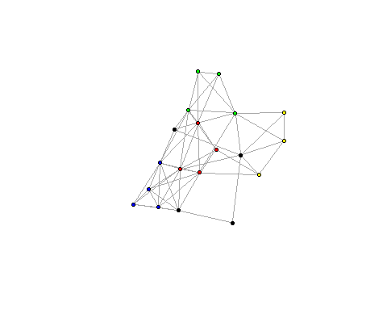

table(sapply(cliques(g_3),length))

##   
## 1 2 3 4 5 6   
## 19 57 61 36 12 2

cliques(g_3) [sapply(cliques(g_3), length) == 6]

## [[1]]  
## + 6/19 vertices, named, from 60cdc51:  
## [1] Waleed.Alshehri Wail.Alshehri Satam.Suqami   
## [4] Abdul.Aziz.Al.Omari Marwan.Al.Shehhi Fayez.Ahmed   
##   
## [[2]]  
## + 6/19 vertices, named, from 60cdc51:  
## [1] Mohamed.Atta Wail.Alshehri Satam.Suqami   
## [4] Abdul.Aziz.Al.Omari Marwan.Al.Shehhi Fayez.Ahmed